Connecting DB using Python Backend

Task-
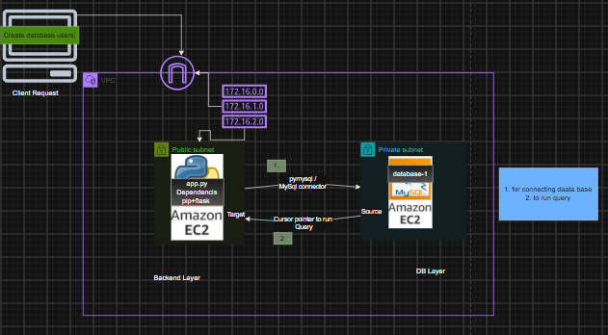
Prerequisite:-

- one Backend server( in this case a - Bastion Host).
- Install Python and its dependencies( pip +flask +pymysql or Mysql connector + flask_cors)
- Create app.py to store appliaction code.
- one AWS RDS database in private subnet(as of now give public access).
- MySql workbench for testing only ,in real time will use frontend layer.
- Now configure app.py in Backend-server (Bastion) to communicate with RDS database-1 .
- Then run app.py application and fetch DB details .

Steps:
- Create Bastion Host and configure python for backend.
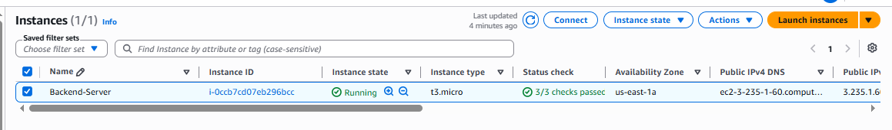
- Install python $sudo yum install python –y
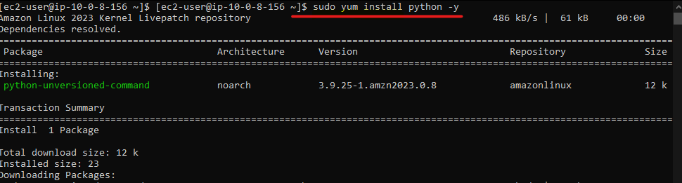

You can check if its installed or not by $python --version
- Install package manager $sudo yum install python-pip –y
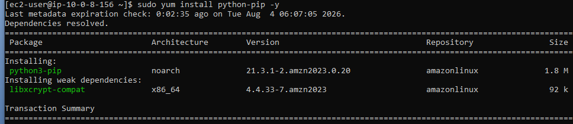

- Install $ pip install pymysql
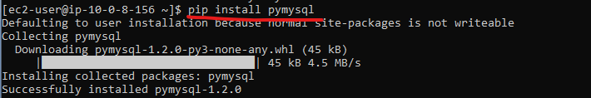
- Same way install flask , flask_cors and mysql-connector-python(no required if we have installed pymysql)
[instead of installing individual package , we can mention packages inside requirements.txt , to install all the packages at a time] here we have not implement this its for knowledge.as of you can ignore
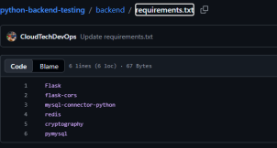

- Create one AWS RDS database in private subnet(as of now give public access).
- Create a public database
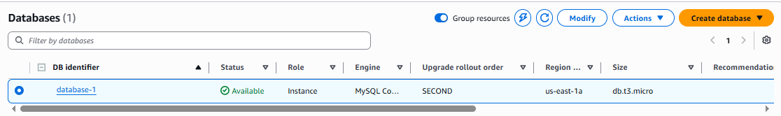

- Note the endpoint dns > database-1.c6xkgac6c5dq.us-east-1.rds.amazonaws.com

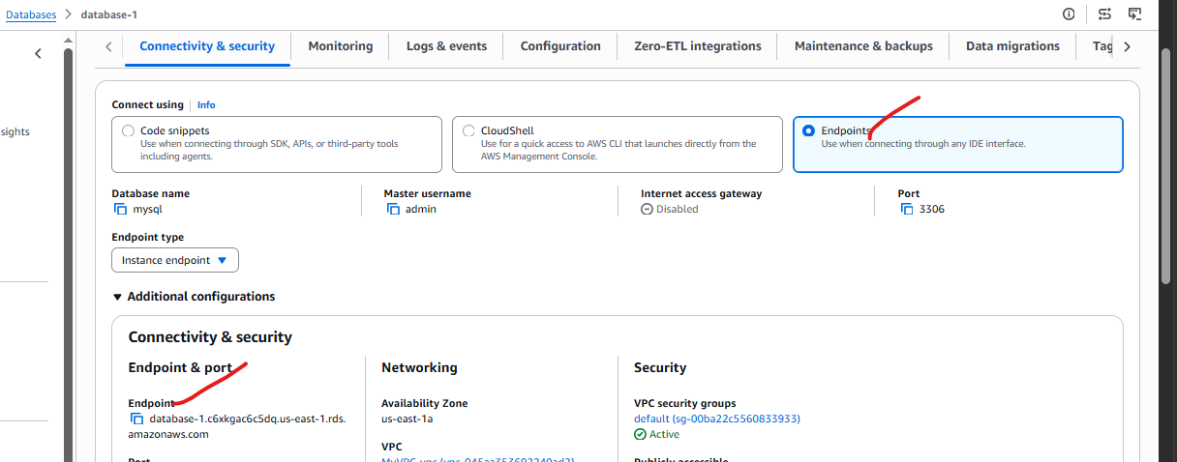

- Now Test the connection to RDS database-1 via MySql Workbench.
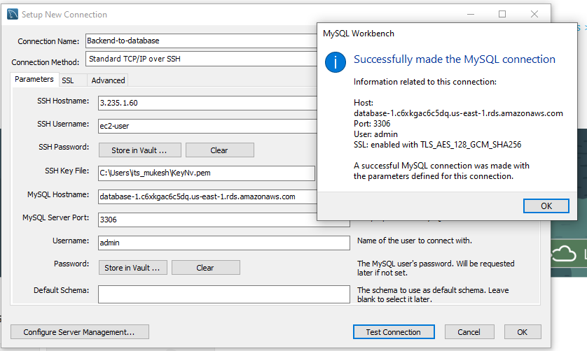
Below you can see we were able to communicate with DB using MYSQL workbench in our local system.
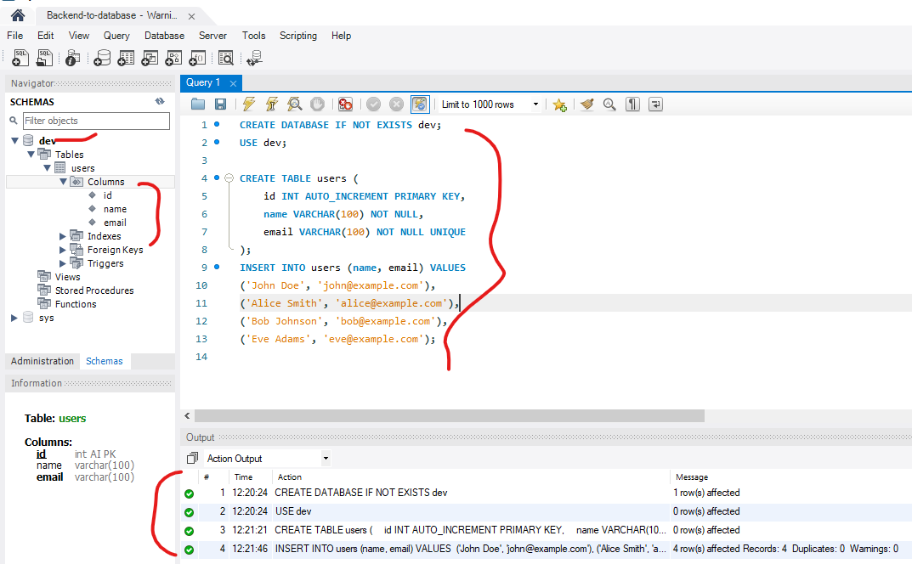

- Now configure app.py to communicate with RDS database-1

Login into Backend-server (Bastion host) > open app.py file > paste below backend code.
from flask import Flask, request, jsonify
from flask_cors import CORS
import mysql.connector
from mysql.connector import Error

app = Flask(__name__)
CORS(app) #enable CORS for all routes

# =========================
# DATABASE CONFIG
# =========================

# ✍️ Writer (Master)
db_write_config = {
'host': 'database-1.c6xkgac6c5dq.us-east-1.rds.amazonaws.com',
'user': 'admin',
'password': 'AdminMukesh',
'database': 'dev'
}

# 👀 Reader (Read Replica Endpoint)
db_read_config = {
'host': 'database-1.c6xkgac6c5dq.us-east-1.rds.amazonaws.com',
'user': 'admin',
'password': 'AdminMukesh',
'database': 'dev'
}

# =========================
# CONNECTION HELPERS
# =========================

def get_write_connection():
return mysql.connector.connect(**db_write_config)

def get_read_connection():
return mysql.connector.connect(**db_read_config)

def get_db_info(cursor):
cursor.execute("SELECT @@hostname AS host, @@read_only AS read_only")
return cursor.fetchone()

# =========================
# ROUTES
# =========================

@app.route('/')
def index():
return "API is running"

# =========================
# READ APIs (Reader DB)
# =========================

@app.route('/users', methods=['GET'])
def get_users():
try:
conn = get_read_connection()
cursor = conn.cursor(dictionary=True)

cursor.execute("SELECT * FROM users")
users = cursor.fetchall()

db_info = get_db_info(cursor)

return jsonify({
"data": users,
"served_by": db_info["host"],
"read_only": db_info["read_only"],
"db_role": "READER" if db_info["read_only"] == 1 else "WRITER"
})
except Error as err:
return jsonify({'error': str(err)}), 500
finally:
cursor.close()
conn.close()

@app.route('/users/<int:user_id>', methods=['GET'])
def get_user(user_id):
try:
conn = get_read_connection()
cursor = conn.cursor(dictionary=True)

cursor.execute("SELECT * FROM users WHERE id = %s", (user_id,))
user = cursor.fetchone()

if not user:
return jsonify({'error': 'User not found'}), 404

db_info = get_db_info(cursor)

return jsonify({
"data": user,
"served_by": db_info["host"],
"read_only": db_info["read_only"],
"db_role": "READER" if db_info["read_only"] == 1 else "WRITER"
})
except Error as err:
return jsonify({'error': str(err)}), 500
finally:
cursor.close()
conn.close()

# =========================
# WRITE APIs (Master DB)
# =========================

@app.route('/users/add', methods=['POST'])
def add_user():
data = request.json
name = data.get('name')
email = data.get('email')

if not name or not email:
return jsonify({'error': 'Name and Email are required'}), 400

try:
conn = get_write_connection()
cursor = conn.cursor()
cursor.execute(
"INSERT INTO users (name, email) VALUES (%s, %s)",
(name, email)
)
conn.commit()
return jsonify({'message': 'User added successfully'}), 201
except Error as err:
return jsonify({'error': str(err)}), 500
finally:
cursor.close()
conn.close()

@app.route('/users/update/<int:user_id>', methods=['PUT'])
def update_user(user_id):
data = request.json
name = data.get('name')
email = data.get('email')

if not name or not email:
return jsonify({'error': 'Name and Email are required'}), 400

try:
conn = get_write_connection()
cursor = conn.cursor()

cursor.execute("SELECT id FROM users WHERE id = %s", (user_id,))
if not cursor.fetchone():
return jsonify({'error': 'User not found'}), 404

cursor.execute(
"UPDATE users SET name = %s, email = %s WHERE id = %s",
(name, email, user_id)
)
conn.commit()
return jsonify({'message': 'User updated successfully'})
except Error as err:
return jsonify({'error': str(err)}), 500
finally:
cursor.close()
conn.close()

@app.route('/users/delete/<int:user_id>', methods=['DELETE'])
def delete_user(user_id):
try:
conn = get_write_connection()
cursor = conn.cursor()

cursor.execute("SELECT id FROM users WHERE id = %s", (user_id,))
if not cursor.fetchone():
return jsonify({'error': 'User not found'}), 404

cursor.execute("DELETE FROM users WHERE id = %s", (user_id,))
conn.commit()
return jsonify({'message': 'User deleted successfully'})
except Error as err:
return jsonify({'error': str(err)}), 500
finally:
cursor.close()
conn.close()

# =========================
# ENTRY POINT
# =========================
if __name__ == '__main__':
app.run(host='0.0.0.0', port=5000, debug=True)

- Then run app.py application and fetch DB details .

- Run app.py $python app.py

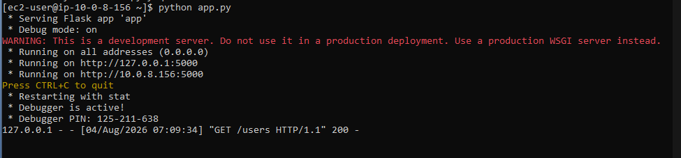

Since the service is running on Interactive session , you can open a new terminal and try to create ,retrive (fetch), updated and delete (CRUD) .
curl -X GET http://localhost:5000/users

curl -X POST http://localhost:5000/users/add \
-H "Content-Type: application/json" \
-d '{"name":"John Doe","email":"john@example.com"}'

curl -X PUT http://localhost:5000/users/update/1 \
-H "Content-Type: application/json" \
-d '{"name":"John Updated","email":"john.updated@example.com"}'

curl -X DELETE http://localhost:5000/users/delete/1
```

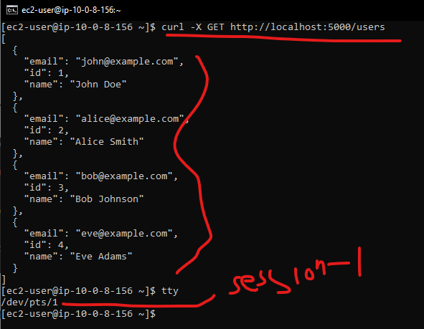

You can also check the process ($ps aux |grep python) and port
(ss -tuln)

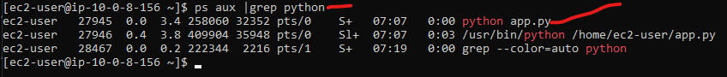

Python Service is running on port :5000
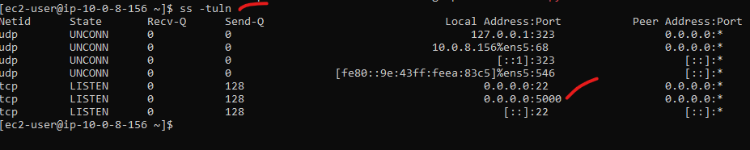

Conclusion – Backend server (Bastion host )is communicating with RDS database -1 .

Task Over

